**Hospital Management System**

### Submitted By

| **Student Name** | **Student ID** |
| --- | --- |
| Noymul Matin Jim | 0242220005101671 |
| Mehedi Hasan Hira | 0242220005101742 |
| Afjal | 0242220005101730 |
| Md.Mezbah Uddin Tanim | 0242220005101611 |
| Zarin Tasnim Dia | 0242220005101931 |

**MINI LAB PROJECT REPORT**

This Report Presented in Partial Fulfillment of the course

**CSE312: Database Management System**



### DAFFODIL INTERNATIONAL UNIVERSITY

**Dhaka, Bangladesh**

**December 11, 2024**

## DECLARATION

We hereby declare that this lab project has been done by us under the supervision of **Md. Shah Jalal, Senior Lecturer,** Department of Computer Science and Engineering, Daffodil International University. We also declare that neither this project nor any part of this project has been submitted elsewhere as lab projects.

**Submitted To:**

*Md. Shah Jalal*

Senior Lecturer,

Department of Computer Science and Engineering

Daffodil International University

©Daffodil International University i

**Submitted by**

| Noymul Matin jim  ID:0242220005101671  Dept. of CSE, DIU | |
| --- | --- |
| Mehedi Hasan Hira  ID:0242220005101742  Dept. of CSE, DIU | Afjal  ID:0242220005101730  Dept. of CSE, DIU |
| MD. Mezbah UddinTanim  ID:0242220005101611  Dept. of CSE, DIU | Zarin Tasnim Dia  ID:0242220005101931  Dept. of CSE, DIU |

©Daffodil International University ii

## COURSE & PROGRAM OUTCOME

The following course have course outcomes as following:.

Table 1: Course Outcome Statements

| **CO’s** | **Statements** |
| --- | --- |
| CO1 | Demonstrate a comprehensive understanding of fundamental database management concepts, including the relational data model, normalization techniques, and SQL basics |
| CO2 | Design, implement and optimize relational databases, incorporating advanced SQL queries, indexing techniques and query optimization strategies. |
| CO3 | Understand and analyze security measures, distributed database architectures and emerging trends in database management, demonstrating an understanding of the broader context and challenges in the field. |

Table 2: Mapping of CO, PO, Blooms, KP and CEP

| **CO** | **PO** | **Blooms** | **KP** | **CEP** |
| --- | --- | --- | --- | --- |
| CO1 | PO1 | C1, C2 | KP3 | EP1, EP3 |
| CO2 | PO2 | C2 | KP3 | EP1, EP3 |
| CO3 | PO3 | C4, A1 | KP3 | EP1, EP2 |

The mapping justification of this table is provided in section **4.3.1**, **4.3.2** and **4.3.3**.

©Daffodil International University iii

# Table of Contents

**Declaration** **i**

**Course & Program Outcome** v

1. **Introduction** **1**
   1. Introduction 1
   2. Motivation 1
   3. Objectives 2
   4. Feasibility Study 3
   5. Gap Analysis 3
   6. Project Outcome 3
2. **Proposed Methodology/Architecture** **4**
   1. Requirement Analysis & Design Specification t 4
      1. OverView…………………………………………………………………………….. 6
      2. Proposed Methodology/ System Design—-------------------------------------------------- 7
      3. Ui Design 7
   2. Overall Project Plan 8
3. **Implementation and Results** **9**
   1. Implementation 10
   2. Performance Analysis 10
   3. Results and Discussion 10
4. **Engineering Standards and Mapping** **11**
   1. Impact on Society, Environment and Sustainability 11
      1. Impact on Life 11
      2. Impact on Society & Environment 11
      3. Ethical Aspects 11
      4. Sustainability Plan 11
   2. Project Management and Team Work 12
   3. Complex Engineering Problem 12
      1. Mapping of Program Outcome 12
      2. Complex Problem Solving 12
      3. Engineering Activities 13

©Daffodil International University **i**v

Table of Contents Table of Contents

1. **Conclusion** **14**
   1. Summary 14
   2. Limitation 14
   3. Future Work 14

**References** **15**

©Daffodil International University v

**Chapter 1**

**Introduction**

The introduction chapter provides an overview of the Quick Doctor, including its purpose, objectives, and scope. It outlines the significance of the project in enhancing hospital operations and introduces the key features implemented using MySQL.

### Introduction

Hospitals often face inefficiencies in managing patient records, scheduling, and administrative tasks due to reliance on manual processes. This project aims to address these issues by developing a centralized system to streamline operations, reduce errors, and enhance healthcare delivery.

Hospitals often struggle with inefficient data management, leading to delays in patient care, miscommunication among staff, and errors in record-keeping. Manual processes are time-consuming and prone to inaccuracies, impacting the overall quality of healthcare services. Additionally, the lack of a centralized system makes it challenging to access and analyze critical data promptly. This project aims to solve these issues by developing a Hospital Management System that ensures accurate data handling, streamlines operations, and improves coordination across departments.

### Motivation

The selection of this project is driven by the need to leverage computational technologies to enhance hospital management efficiency. By utilizing MySQL, the system enables robust data storage, retrieval, and manipulation for real-time decision-making. Advanced database features like views, triggers, and joins provide scalable solutions to handle complex healthcare data. This approach not only ensures accuracy and reliability but also optimizes operational workflows in a healthcare environment.

Solving this problem will enhance my understanding of database management and system design, equipping me with practical skills in MySQL and software development. Additionally, it provides an opportunity to contribute to real-world solutions that improve healthcare efficiency and patient outcomes.

### Objectives

* **Efficient Data Management:** To design a centralized database system for accurate and efficient storage, retrieval, and management of hospital data.
* **Streamlined Operations:** To automate critical processes such as patient management, appointment scheduling, and billing to reduce administrative workload and errors.

©Daffodil International University 1

* **Enhanced Decision-Making:** To provide real-time data insights through advanced features like views and triggers, enabling better coordination and informed decision-making in hospital operations.
* **Configure and Manage IP Addresses:** To establish an organized IP addressing scheme for effective device management and optimal network performance.

### Feasibility Study

The feasibility study evaluates the technical, operational, and economic aspects of existing hospital management systems to identify key limitations and areas for improvement. It provides insights into the gaps present in manual and basic digital systems, highlighting the need for a more integrated and scalable solution. **[1].**

| **Feasibility Aspect** | **Case Study 1:Hospital Management Software** |
| --- | --- |
| **Technical Feasibility** | Existing System: Automates some hospital tasks like patient registration and billing but lacks scalability, real-time synchronization, and integration with other systems like lab reports. |
| **Gap Identified** | The system provides basic functionalities but lacks advanced features like data analytics, real-time updates, and multi-department integration, reducing its usability and efficiency in modern healthcare settings. |
| **Operational Feasibility** | Existing System: Automates basic functions but does not integrate other hospital departments effectively, causing delays in patient care and communication. |
| **Gap Identified** | Limited inter-departmental integration makes coordination difficult, leading to fragmented patient care and inefficiency. |

©Daffodil International University 2

### Gap Analysis

The gap analysis from the feasibility study highlights significant shortcomings in both systems. The manual system lacks scalability, real-time data access, and centralized information, leading to inefficiency and errors. The digital system, while automating basic tasks, lacks advanced features like real-time updates and inter-departmental integration, hindering its overall effectiveness. Both systems require improvements in scalability, integration, and automation to meet the evolving needs of modern healthcare management.

### Project Outcome

* **Improved Data Management:** A centralized system for efficient storage, retrieval, and management of patient and hospital data, reducing errors and delays.
* **Streamlined Hospital Operations:** Automation of key processes like patient registration, appointment scheduling, and billing, improving workflow and reducing manual labor.
* **Enhanced Decision-Making:** Real-time data access and analytics features enabling better coordination among departments and informed decision-making for hospital management.

©Daffodil International University 3

**Chapter 2**

# Proposed Methodology/Architecture

The Proposed Methodology/Architecture chapter will outline the system design, including the technologies used, database structure, and the workflow for implementing the Quick Doctor

### Requirement Analysis & Design Specification

#### 2.1.1 Overview

The following steps outline the project approach:

**1. Idea Selection**

* We began by brainstorming ideas for a meaningful and practical project that could address real-world problems.
* After thorough discussions, we decided on developing a **Hospital Management System** to streamline hospital operations and improve patient care.

**2. Feature Selection and Planning**

* We conducted research on the common functionalities required in hospital management systems.
* Key features like patient registration, appointment scheduling, billing, doctor management, inventory management, and report generation were finalized.
* We created a project blueprint detailing the workflow and data requirements for each feature.

**3. Database Design**

* Using the features as a guide, we designed a relational database with 15 tables to store data related to patients, doctors, appointments, billing, inventory, etc.
* We focused on normalization to eliminate redundancy and ensure efficient data storage.

**4. Implementation Using MySQL**

* We created the database schema in MySQL, defining tables with appropriate fields, data types, and constraints.
* SQL queries were written to handle data insertion, updates, and retrieval.
* **Joins** were implemented to connect data across multiple tables and provide meaningful insights.
* **Views** were created for commonly used queries, enhancing efficiency and simplifying report generation.  ***4***

**5. Adding Advanced Features**

* **Triggers** were added to automate specific tasks, such as updating stock in the inventory when medicines were issued.
* Validation constraints were implemented to ensure data integrity, like checking for duplicate entries or invalid appointment times.

**6. Testing the System**

* We conducted rigorous testing to identify and fix errors in the database design and SQL queries.
* Various test cases were run to ensure the correctness of features like patient registration, billing calculations, and appointment scheduling.

**7. Finalizing the Project**

* After testing, we refined the system by improving the database design, optimizing queries, and ensuring all features worked seamlessly.
* A flowchart was created to represent the system workflow visually, aiding in better understanding and presentation.

©Daffodil International University 5

#### 2.1.2 Proposed Methodology/ System Design

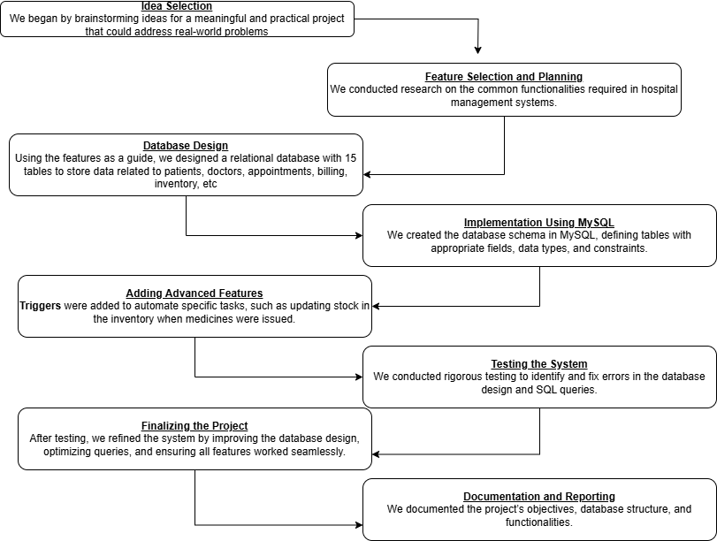

#### 2.1.3 Ui Design

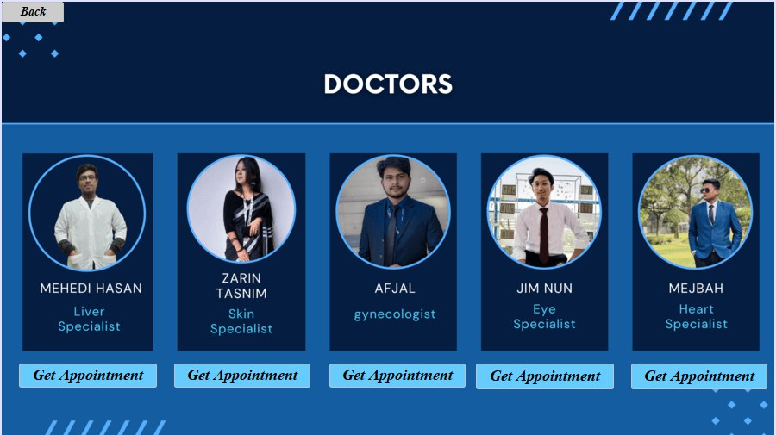

©Daffodil International University 7

### Overall Project Plan

The project was designed and completed within a span of 20 days, with each phase focused on specific tasks:

**Phase 1:** Planning and Requirement Analysis (Days 1–3)

- Finalizing the project idea.

- Identifying key features.

- Drafting the initial workflow and requirements.

**Phase 2:** Database Design (Days 4–7)

- Creating ERD and designing tables.

- Defining relationships and constraints.

- Implementing and optimizing the database schema.

**Phase 3:** SQL Query Development (Days 8–12)

- Writing basic SQL queries.

- Implementing joins and views.

- Adding triggers and testing queries.

**Phase 4:** System Testing and Validation (Days 13–16)

- Testing individual features and database validation.

- Fixing bugs and optimizing performance.

**Phase 5:** Finalization and Documentation (Days 17–20)

- Preparing diagrams and documentation.

- Compiling the project report.

- Reviewing and preparing for a presentation.

©Daffodil International University 8

**Chapter 3**

# Implementation and Results

The "Implementation and Results" chapter will detail the step-by-step process of system development, including database creation, feature implementation, and a summary of results validated through testing.

### Implementation

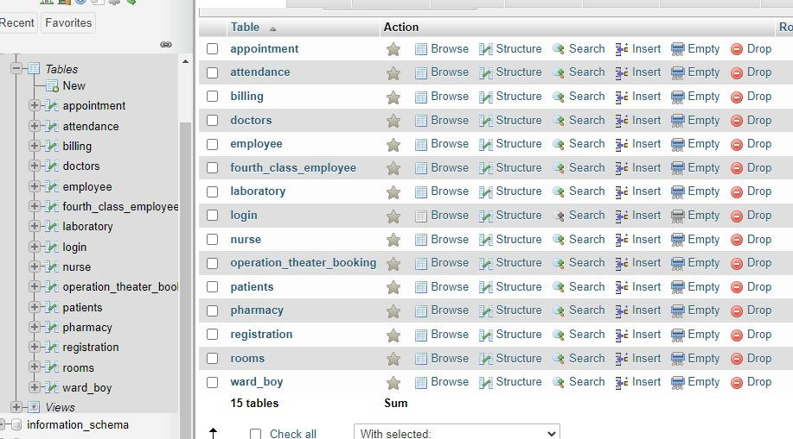

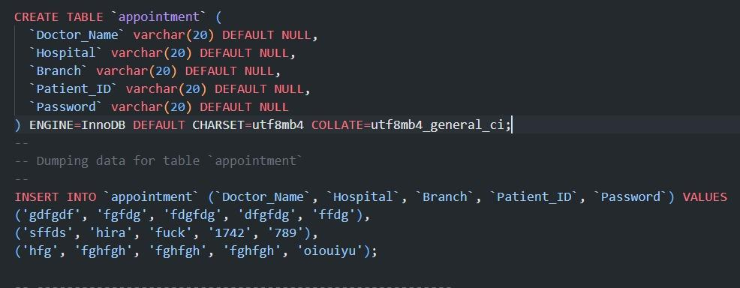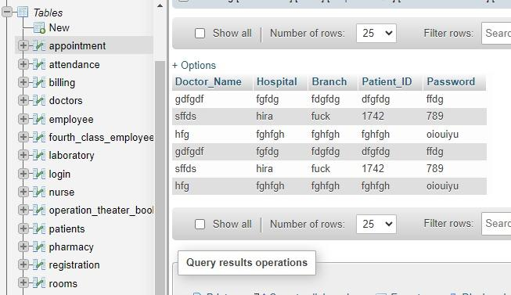

©Daffodil International University 9

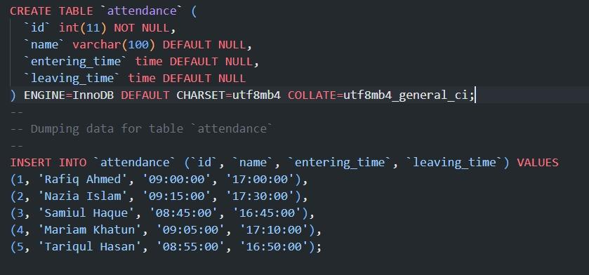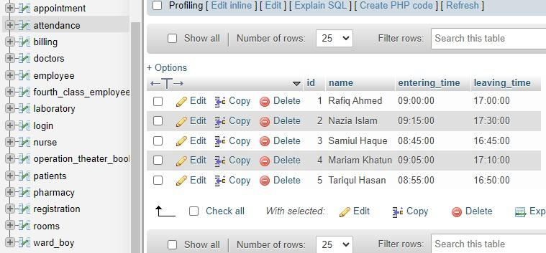

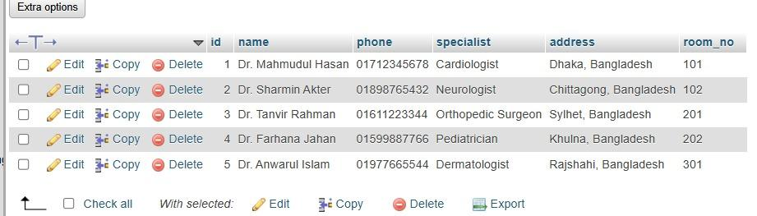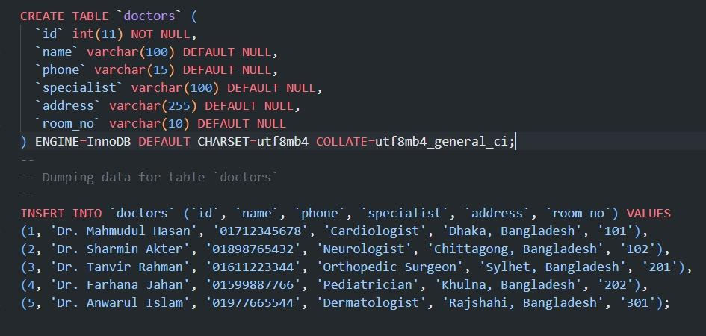

### Performance Analysis

**Database Efficiency:** The system utilizes a normalized database with optimized queries, ensuring minimal redundancy and quick data retrieval.

**System Reliability:** Key features like registration, billing, and inventory updates were rigorously tested to ensure accurate and consistent performance.

**Scalability and Maintenance:** The modular design supports future feature additions, with clear documentation to facilitate maintenance.

### Results and Discussion

The hospital management system was successfully implemented with 15 tables, optimized queries, views, and triggers. It efficiently handles patient management, billing, appointments, and inventory with accurate and reliable performance.

**Notable Point:** A notable point of your hospital management system project is the integration of views and joins across multiple tables, which significantly enhances data retrieval efficiency and simplifies complex reporting tasks like patient history and billing summaries.

©Daffodil International University 10

**Chapter 4**

# Engineering Standards and Mapping

The "Engineering Standards and Mapping" chapter will outline the technical standards followed during the system design and development, including database design principles, SQL optimization techniques, and how the system maps to industry best practices.

### Impact on Society, Environment and Sustainability

The hospital management system improves healthcare efficiency, ensuring better patient care and streamlined operations, which positively impacts society by reducing errors and enhancing service delivery. Additionally, the system contributes to sustainability by minimizing paper usage and optimizing resource management within healthcare facilities.

#### Impact on Life

The hospital management system significantly enhances the quality of life by ensuring timely and accurate medical services, improving patient care, and reducing administrative burdens on healthcare staff. It also fosters a more efficient healthcare environment, ultimately leading to better outcomes for patients and communities.

#### Ethical Aspects

The ethical aspects of the hospital management system focus on ensuring data privacy, security, and compliance with healthcare regulations while promoting fairness and transparency in service delivery.

#### Sustainability Plan

The sustainability plan for the hospital management system focuses on reducing paper usage, optimizing resource allocation, and ensuring long-term scalability through efficient database design and maintenance.

### Project Management and Team Work

The project was managed collaboratively, with team members taking on specific tasks such as database design, SQL query development, and system testing. Although no external funding was applied, the team efficiently utilized available resources, ensuring effective communication and timely completion through regular progress meetings and shared responsibilities.

©Daffodil International University 11

### Complex Engineering Problem

#### Mapping of Program Outcome

In this section, provide a mapping of the problem and provided solution with targeted Program Outcomes (PO’s).

Table 4.1: Justification of Program Outcomes

| **PO’s** | **Justification** |
| --- | --- |
| PO1 | Demonstrate a comprehensive understanding of fundamental database management concepts, including the relational data model, normalization techniques, and SQL basics  Design, implement and optimize relational databases, incorporating advanced SQL queries, indexing techniques and query optimization strategies. |
| PO2 | Design, implement and optimize relational databases, incorporating advanced SQL queries, indexing techniques and query optimization strategies. |

#### Complex Problem Solving

In this section, provide a mapping with problem solving categories. For each mapping add subsections to put rationale (Use Table 4.2). For P1, you need to put another mapping with

©Daffodil International University 12

Chapter 4. Engineering Standards and Mapping 4.3. Complex Engineering Problem

Knowledge profile and rationale thereof.

Table 4.2: Mapping with complex problem solving.

| **EP1**  Dept of Knowledge | **EP2**  Range of Conflicting Requirements | **EP3**  Depth of Analysis | **EP4**  Familiarity of Issues | **EP5**  Extent of Applicable Codes | **EP6**  Extent  Of Stakeholder Involvement | **EP7**  Inter- dependence |
| --- | --- | --- | --- | --- | --- | --- |
|  |  |  |  |  |  |  |

#### Engineering Activities

In this section, provide a mapping with engineering activities. For each mapping add subsections to put rationale (Use Table 4.3).

Table 4.3: Mapping with complex engineering activities.

| **EA1**  Range of resources | **EA2**  Level of Interaction | **EA3**  Innovation | **EA4**  Consequences for society and  environment | **EA5**  Familiarity |
| --- | --- | --- | --- | --- |
|  |  |  |  |  |

©Daffodil International University 13

**Chapter 5**

# Conclusion

The conclusion chapter will summarize the key achievements of the project, highlight its contributions to improving hospital management, and discuss potential future enhancements and applications.

### Summary

This project developed a hospital management system using MySQL, designed to streamline patient registration, appointment scheduling, billing, and inventory management. The system efficiently handles data through optimized queries, triggers, and views, ensuring accuracy, reliability, and scalability for future expansion.

### Limitation

The project faced challenges due to a limited 20-day timeframe, complex database relationships, and resource constraints, which impacted feature implementation, testing, and performance optimization. Additionally, the lack of a front-end interface limited the overall user experience.

**1. Limited Time Frame:** The 20-day project duration restricted the ability to implement all desired features and conduct extensive testing.

**2. Complex Database Relationships:** Designing and managing complex relationships between 15 tables posed challenges in ensuring data integrity and optimizing performance.

**3. Lack of Front-End Development:** As the project focused primarily on the backend (MySQL), creating a user-friendly front-end interface was not a priority, limiting the user experience.

**4. Resource Constraints:** Limited access to external tools, libraries, or advanced software made it challenging to implement some features or optimize performance to the desired level.

### Future Work

* **Integration with Front-End Interface:** Develop a user-friendly front-end interface using technologies like HTML, CSS, and JavaScript, or frameworks like React or Flutter, to improve user interaction with the system.
* **Real-Time Data Integration:** Implement real-time data synchronization with external systems such as electronic health records (EHR) and medical devices for more accurate and timely patient information.
* **Advanced Analytics and Reporting:** Add advanced reporting features and data analytics, using machine learning algorithms to predict patient trends, optimize inventory management, and improve decision-making.

©Daffodil International University 14

# References

# 

# [1] Ankit Dudhwewala,Hospital Management Software,Caresoft Hospital Information System,India

©Daffodil International University 15